Author
BIT/2024/57502
AUTOCAD DOCUMENTATION
Computer Graphics Assignment

Table of Contents
Architectural Floor Plan Analysis 2
Structural Elements: Walls, Doors, and Windows 2
Room Layout: Offices, Corridors, and Washrooms 3
Use of Layers and Line Types 3
Water Supply and Plumbing Plan 4
Material Specifications 5
Component Infrastructure 5
System Layout and Routing Diagram 5
Wi-Fi and Network Cabling Plan 6
Wi-Fi Infrastructure & Access Point Locations 6
Distribution Switches (IDF) 7
Wi-Fi Access Point Locations 7
Data Cabling Routes 7
Proper Labeling and Symbols 8
Electrical Wiring Layout 9
Main Power Supply Line 9
Distribution Panels 9
Lighting Points and Socket Outlets 10
Switch Positions and Emergency Systems 10
Electrical Symbols and Legends 10

Architectural Floor Plan Analysis

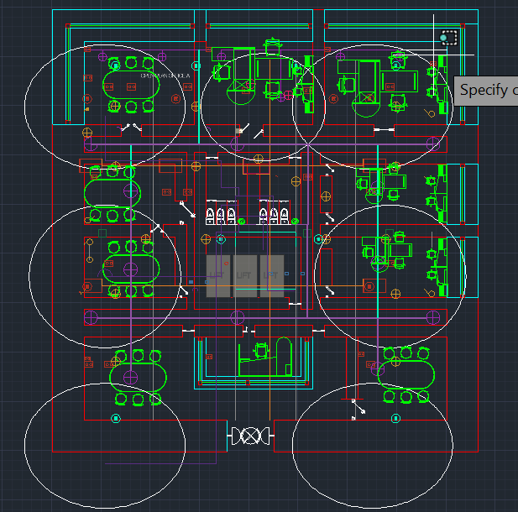

Structural Elements: Walls, Doors, and Windows

The plan utilizes a clear color-coding system to differentiate between various structural components:
  - Walls: The primary structural and partitioning walls are rendered in solid blue, indicating standard interior partitions. Thicker magenta-colored zones represent the building's exterior envelope or major structural shear walls.
  - Doors: Entryways are clearly marked with white door-swing symbols. The main entrance at the bottom features a double-door configuration, while individual offices utilize single-swing doors to maximize usable floor space.

  - Windows/Glazing: External window units are indicated along the right-hand and top perimeters using cyan/light blue outlines within the magenta wall sections, ensuring natural light reaches the outer office tiers.

Room Layout: Offices, Corridors, and Washrooms

The layout follows a "central core" design philosophy to maximize efficiency:

  - Offices and Meeting Rooms: The perimeter is lined with seven distinct work areas. These include larger rooms with oval conference tables for collaborative work and smaller rectangular offices for focused tasks.
  - Corridors: A central circulation corridor (outlined by the blue partitions) provides a clear path from the main entrance to every room in the facility, ensuring logical traffic flow.
  - Washrooms/Service Core: The center of the plan features a dedicated service core containing two washroom cubicles (identified by the white plumbing fixture symbols). This central placement minimizes the length of plumbing runs and ensures equal access for all staff members.
  - Reception: A dedicated reception or security desk is located immediately adjacent to the main entrance to manage visitor flow.

Use of Layers and Line Types

The drawing adheres to standard CAD layering conventions to maintain technical clarity:
  - Furniture Layer: Rendered in green, this layer includes desks, chairs, and conference tables, allowing them to be toggled for space-planning purposes.
  - Structural Layer: Uses blue and magenta for walls, providing a clear hierarchy between load-bearing and non-load-bearing elements.
  - Fixtures Layer: Rendered in white/yellow, specifically used for plumbing fixtures and door swings to distinguish them from the building's shell.

Circulation and Accessibility

  - Egress: The wide central corridor and double-entry doors suggest a design compliant with fire safety standards for rapid evacuation.
  - Elevator/Stairwell Provision: While not explicitly detailed with icons in this view, the large hollow rectangular zone in the center-left likely serves as the main
vertical circulation shaft (elevator or staircase) for the building.

Water Supply and Plumbing Plan
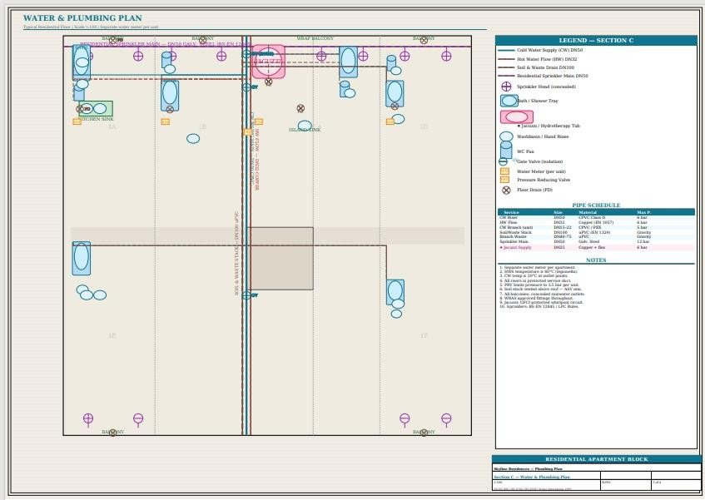
This report details the plumbing infrastructure and water distribution strategy for the Residential Apartment Block as specified.
The plumbing design for this project follows a multi-service approach, integrating domestic water supply with fire suppression systems.
  - Domestic Hot Water: The Hot Water System (HWS) is engineered to maintain a constant temperature of 60°C.
  - Regulatory Compliance: Materials and installations must adhere to WRAS (Water Regulations Advisory Scheme) standards and BS EN 12056/806 equivalent codes.
  - Fire Protection: The design includes a resolute DN50 Residential Sprinkler Main feeding concealed sprinkler heads to maintain aesthetic integrity in residential spaces.

Material Specifications
The project utilizes specific materials based on the fluid type and pressure requirements.

Service | Material Specification | Size/Ref
Cold Water (CWS) | CPVC | DN50 (Main)
Hot Water (HWS) | Copper (EN 1057) or PEX | DN12
Sanitary/Waste | PVC | DN100
Fire Mains | CPVC | DN50

Component Infrastructure
The layout ensures individual accountability and pressure management through the following mechanical components:
  - Water Metering: Each unit is equipped with an individual Water Meter to allow for precise consumption tracking.
  - Pressure Management: A Pressure Reducing Valve (PRV) is installed per unit/branch to prevent pipe hammer and protect fixtures from high-pressure surges.
  - Valving: Gate Valves are utilized for system isolation during maintenance.

System Layout and Routing Diagram
The following diagram illustrates the logical flow from the main inlet through the vertical risers to the individual washroom connections.

Main Water Inlet & Risers
- Inlet: The DN50 Cold Water Supply enters the building footprint, at a ground-level plant room or service duct.
- Vertical Risers: Main pipes for CWS, HWS, and Sprinklers run vertically through a central service.
- Branching: From the vertical stack, DN32-22 horizontal pipes branch out to serve the individual apartments.

Washroom and Fixture Connections
The plan accounts for high-density plumbing in the washroom zones:

- Sanitary Fixtures: Connections are provided for WC Pans, Wash hand Basins, and Flush Shower Trays.
- Luxury Fittings: Provisions are included for Jacuzzis or Hydrotherapy Tubs, requiring specific drainage and high-flow supply.
- Drainage: All fixtures are vent into the DN100 Soil and Waste Drain, with Floor Drains (FD) installed to prevent flooding in wet areas.

External Areas
- The plumbing extends to the Wrap Balcony areas, for drainage or secondary maintenance taps.

Wi-Fi and Network Cabling Plan

Wi-Fi Infrastructure & Access Point Locations
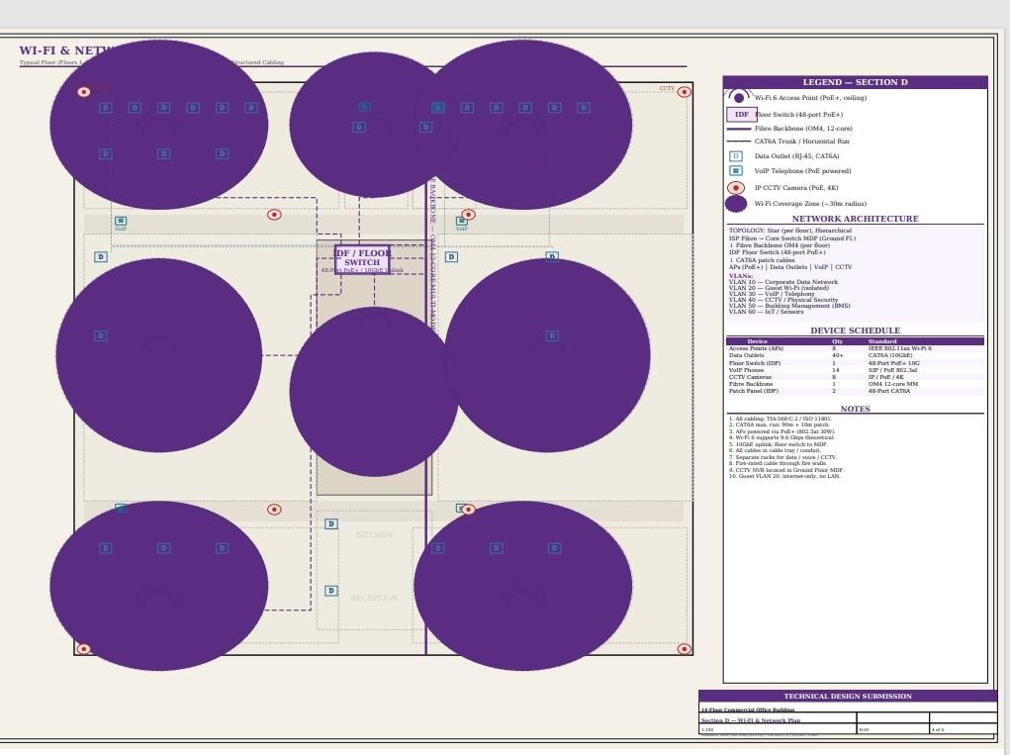

Network Backbone
The backbone serves as the central highway for data transmission between floors and the main server room.
- Vertical Connectivity: The design utilizes a 12-core OM4 Multi-Mode Fiber Backbone per floor.
- Backbone Termination: The ISP Fiber enters at the Core Switch MDF Main Distribution Frame located on the Ground Floor.
- Performance: A 10GbE uplink connects each floor's distribution switch back to the MDF to prevent bandwidth bottlenecks.

Distribution Switches (IDF)
Each floor is equipped with its own IDF (Intermediate Distribution Frame) to manage local traffic.
- Switch Specification: The plan specifies a 48-Port PoE+ Floor Switch with 10G uplink capabilities.
- Patching: The switch is supported by two 48-Port CAT6A patch panels to manage the incoming horizontal cabling.
- Power Delivery: The switch provides PoE+ (802.3at) to power devices such as Access Points, VoIP phones, and CCTV cameras directly through the data cable.

Wi-Fi Access Point Locations
The wireless layout is designed for high-density usage and seamless roaming.

- Deployment: There are 8 Access Points strategically distributed across the typical floor plan.
- Standard: The hardware follows the IEEE 802.11ax Wi-Fi 6 standard, supporting up to
9.6 Gbps.
- Coverage Zones: Each AP is positioned to provide a 30m radius coverage zone, indicated by the purple circular overlays in the design.
- Mounting: All APs are ceiling-mounted for unobstructed signal propagation.

Data Cabling Routes
Physical wiring follows a structured cabling approach to ensure reliability and ease of maintenance.
- Horizontal Runs: The plan utilizes CAT6A Trunk/Horizontal runs for all copper connectivity.
Routing Path: Cables are routed through dedicated cable trays or conduits to provide physical protection.
- Constraint Compliance: All CAT6A runs are limited to a 90m maximum run plus 10m for patch cables, adhering to TIA-568-C.2 standards.
- Fire Safety: All cabling routes passing through fire walls are equipped with fire-rated seals.

Proper Labeling and Symbols
To ensure clarity for installation teams, the plan uses a standardized Legend:

- IDF (Purple Square): Floor Switch location.
- D (Blue Box): Data Outlet (RJ-45, CAT6A).
- Telephone Icon: VoIP Telephone (PoE powered).
- Red Dot with CCTV Label: IP CCTV Camera (PoE, 4K).
- Dashed Lines: Represent the CAT6A horizontal cabling routes from the IDF to the endpoint

Electrical Wiring Layout
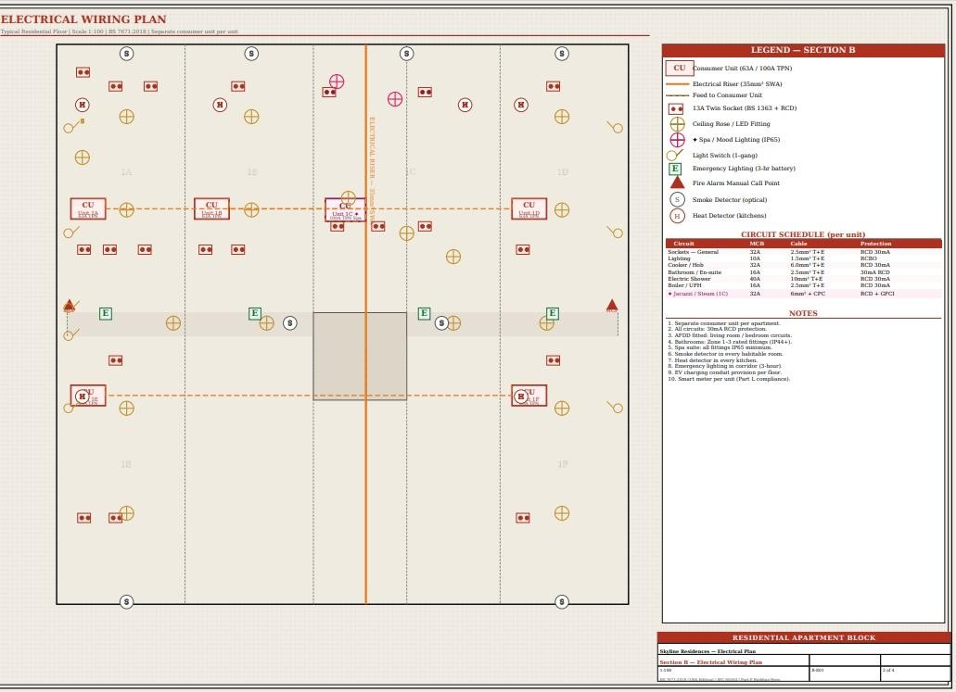

Main Power Supply Line
The building utilizes a high-capacity vertical distribution strategy to ensure power stability across all units.
- Vertical Riser: The primary power feed is a 35mm² SWA (Steel Wire Armored) Electrical Riser that runs vertically through the center of the building core.
- Unit Feed: From this central riser, dedicated horizontal feeds tap off to supply the individual Consumer Units within each apartment.
- Compliance: The system is designed to BS 7671:2018 standards and includes provisions for Part L compliance via smart meters per unit.

Distribution Panels
Power distribution is decentralized to provide localized control and safety isolation for each residence.

- Unit Specifications: Each apartment is equipped with a 63A / 100A TPN Consumer Unit.
- Safety & Protection: All circuits are fitted with 30mA RCD protection.
- Advanced Safety: AFDDs are fitted specifically for living room and bedroom circuits to prevent electrical fires.

Circuit Schedule:
  - Electric Showers: 40A MCB with 10mm² T+E cable.
  - Cooker/Hob: 32A MCB with 6.0mm² T+E cable.
  - Jacuzzi/Steam (Unit 1C): 32A MCB with 6mm² + CPC and RCD + GFCI protection.

Lighting Points and Socket Outlets
The layout follows a dense grid designed for modern residential requirements.

- General Lighting: Standard Ceiling Rose and LED Fittings are distributed throughout habitable rooms.
- Specialized Lighting: Mood Lighting (IP65) is utilized in high-moisture zones to ensure safety.
- Socket Outlets: Power is delivered through 13A Twin Sockets, which include integrated RCD protection.
- Safety Detectors: Every unit includes Optical Smoke Detectors in habitable rooms and
Heat Detectors specifically in kitchen areas.

Switch Positions and Emergency Systems
- Manual Control: 1-gang Light Switches are positioned at the entrance of each room for intuitive access.
- Life Safety: The common corridor features Fire Alarm Manual Call Points and
Emergency Lighting with a 3-hour battery backup.
- Maintenance: Isolation switches are provided for high-load appliances like the Boiler.

Electrical Symbols and Legends
The plan utilizes a standardized technical legend to ensure accurate installation:

- CU (Red Rectangular Box): Represents the apartment Consumer Unit.
- Red Circle with two dots: Represents a 13A Twin Socket.
- Yellow Circle with Cross: Represents a Ceiling Rose and LED Fitting.
- Green 'E' Box: Represents Emergency Lighting.
- 'S' in Circle: Represents an Optical Smoke Detector

